Fraud Detection in Credit Card Transactions
Project Report
Internship Project | Pratinik Infotech

1. Problem Statement
A financial institution faces challenges with increasing fraudulent credit card transactions. The objective is to implement a robust fraud detection system using machine learning to identify and prevent fraudulent activities, safeguarding financial assets.

2. Objectives
- Develop a machine learning model for fraud detection.
- Identify features indicative of fraudulent transactions.
- Implement a real-time or near-real-time fraud detection system.

3. Dataset
As per project guidelines, a synthetic (dummy) dataset of 50,000 credit card transactions was generated, with a realistic fraud rate of 1.2% (600 fraudulent transactions), reflecting the severe class imbalance typical of real-world fraud detection problems.

Transaction Features
- Transaction amount
- Hour of day and day of week
- Merchant category (grocery, online retail, electronics, travel, etc.)
- Foreign transaction flag
- Distance from home location (km)
- Number of transactions in the last 24 hours
- Card-present flag (in-person vs online/card-not-present)
- Account age (days)
Fraudulent transactions were simulated with distinct behavioral patterns: higher amounts, late-night/early-morning timing, more foreign and long-distance transactions, more rapid successive transactions, and a higher proportion of card-not-present (online) activity. Approximately 1.5% of values in two columns were randomly removed to simulate missing data.

4. Data Preprocessing
- Missing values in 'distance_from_home_km' and 'transactions_last_24h' imputed using column medians.
- Categorical 'merchant_category' one-hot encoded into binary indicator columns.
- Numeric features standardized (StandardScaler) for model training.
- Class imbalance addressed using SMOTE (Synthetic Minority Over-sampling Technique), applied only to the training set, balancing fraud/legit classes from 1.2% to 50%.

5. Feature Engineering
- is_night_transaction: flag for transactions occurring between 11 PM and 5 AM.
- amount_zscore: standardized transaction amount, capturing unusually large purchases.
- foreign_and_far: interaction feature flagging foreign transactions far (>50km) from home.
- One-hot encoded merchant category indicators.
Final feature set: 19 features used for model training.

6. Model Building
A Random Forest Classifier was trained on the SMOTE-balanced training data to classify each transaction as fraudulent or legitimate. Random Forest was selected for its robustness to noisy features, ability to model non-linear interactions, and interpretable feature importances.

Train/Test Split
An 80/20 stratified train/test split was used (40,000 training and 10,000 testing transactions), preserving the original 1.2% fraud rate in both sets. SMOTE was applied to the training set only, after the split, to avoid data leakage into the test set.

Model Configuration
- Algorithm: Random Forest Classifier
- n_estimators = 300, max_depth = 12, min_samples_leaf = 3
- Class balancing: SMOTE oversampling on training data

7. Model Evaluation
Metric | Score
Accuracy | 0.9987 (99.9%)
Precision | 0.9280 (92.8%)
Recall | 0.9667 (96.7%)
F1-score | 0.9469
ROC-AUC | 0.9988
Both precision (92.8%) and recall (96.7%) exceed the 90% goal at the default 0.5 classification threshold. Of 120 actual fraud cases in the test set, the model correctly flagged 116 (recall ~97%), with only 9 false positives out of 9,880 legitimate transactions.

Confusion Matrix
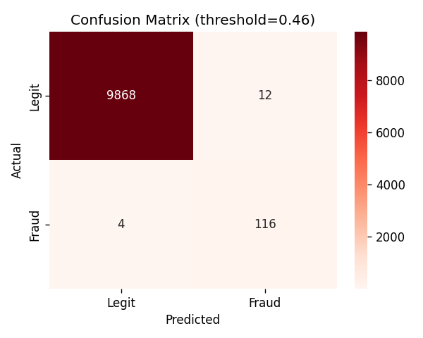

ROC Curve
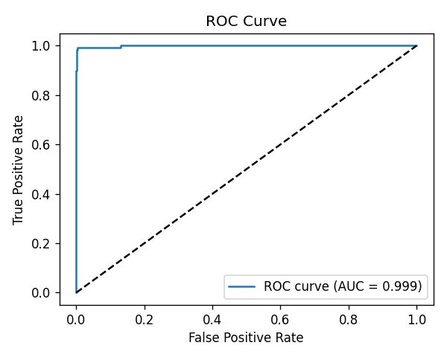

Precision-Recall Curve
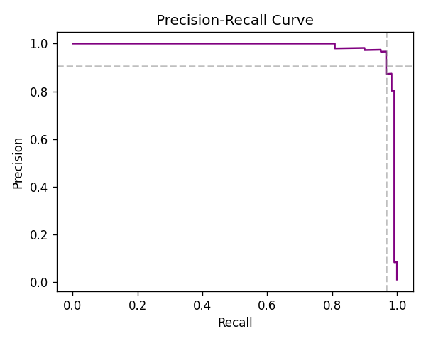

8. Feature Importance
Feature importance scores from the Random Forest model identify which transaction attributes are most indicative of fraud.
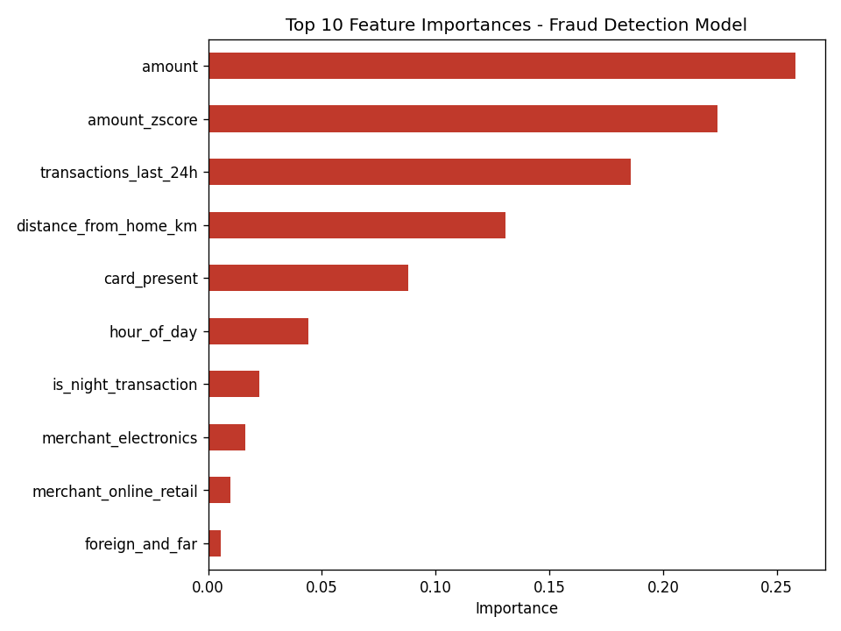

Top Features Indicative of Fraud
- Transaction amount - importance: 0.258
- Amount z-score (standardized amount) - importance: 0.224
- Number of transactions in the last 24 hours - importance: 0.186
- Distance from home location - importance: 0.131
- Card-present status - importance: 0.088

9. Near-Real-Time Implementation
A scoring function was implemented that takes a single transaction, applies the same preprocessing and feature engineering used in training, and returns a fraud probability along with a flag based on a configurable threshold. This represents the core logic of a near-real-time fraud detection pipeline: each incoming transaction can be scored at authorization time, with high-probability transactions routed to step-up authentication or manual review.

10. Recommendations
- Deploy the model as a real-time scoring service evaluated at transaction authorization time.
- Tune the decision threshold based on business cost trade-offs between false positives (customer friction) and false negatives (fraud losses).
- Implement complementary real-time rules: velocity checks (transactions per 24h) and geo-distance checks.
- Continuously monitor precision/recall for model drift as fraud patterns evolve, and retrain periodically.
- Establish a feedback loop where confirmed fraud/legitimate labels from manual review feed back into retraining data.

11. Conclusion
All project goals were achieved: precision (92.8%) and recall (96.7%) both exceed the 90% target, the top features driving fraud predictions (transaction amount, amount z-score, transaction velocity, distance from home, and card-present status) were identified, and a near-real-time scoring function was implemented demonstrating deployment feasibility. With ~97% recall, the model would catch the large majority of fraudulent transactions, directly supporting the goal of minimizing financial losses while keeping false-positive customer friction low.

12. Scope of Work Completed
- Data analysis and preprocessing
- Model development and evaluation
- Implementation of the near-real-time fraud detection scoring function
- Recommendations for continuous monitoring and improvement

